 |  |  | MUMSched: Use Case Description For Admin
Use Case Number: 1
Name |  |  | User Profile CRUD
Brief description |  |  | This use case allows the admin to create profiles for faculty and student
Actors |  |  | Admin
Preconditions
The admin must logged in to the system
Flows of Events:
1. Basic Flows
1.1.0 Create Faculty Profile
Step |  |  | User Actions | System Actions
1 |  | The admin calls the create faculty profile command |  | The system displays the faculty profile form with
 |  |  |  | the fields for firstname, lastname, email, password,
 |  |  |  | specializations, courses and blocks.
2 |  | The Admin fills out the form and requests the system |  | The system verifies that there’s no other profile in
 |  | to save the details |  | the database with the same email address and
 |  |  |  | saves the faculty and returns the success message
 |  |  |  | on success or a fail message in case of failure. In
 |  |  |  | case another profile exists with the email address,
 |  |  |  | the system returns the message indicating a
 |  |  |  | duplicate entry exists.
Postconditions
The staff profile is persisted in the system
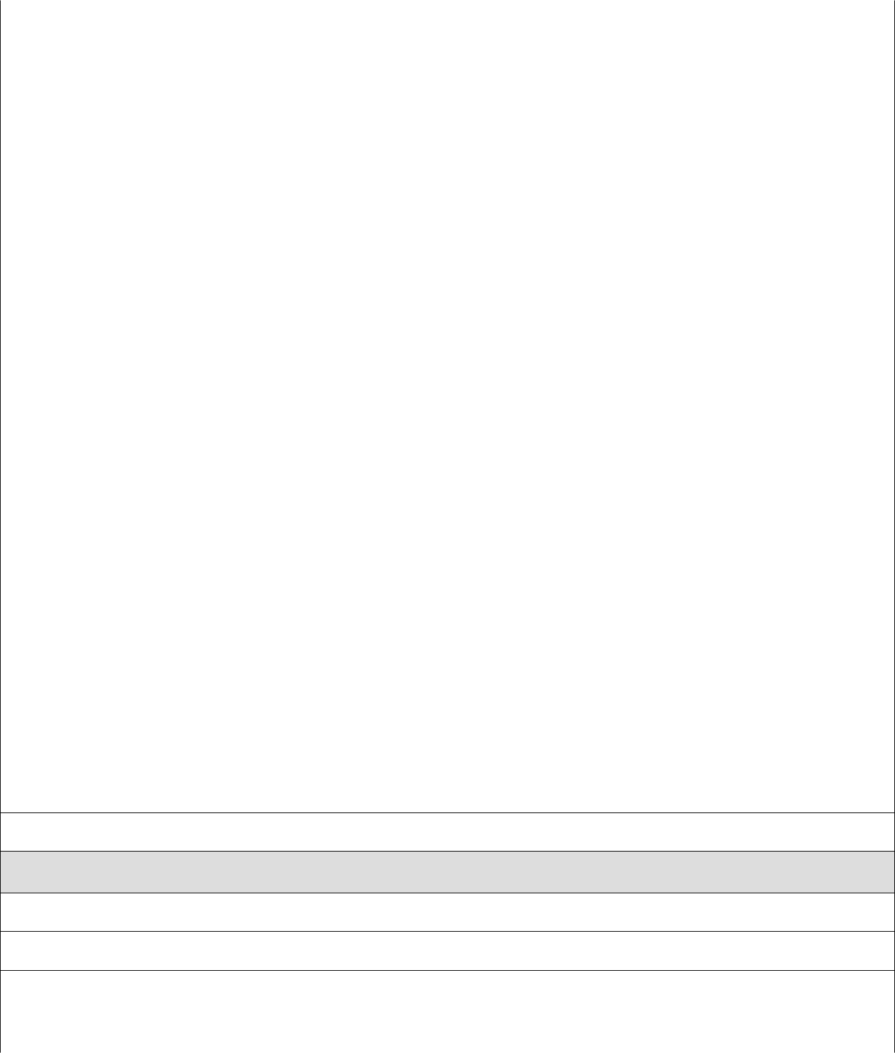

Business Rules

No duplicate faculty profiles. A unique profile is identified by email address.

1.1.1 Read/view Faculty Profile

Step | User Actions | System Actions

1 | The admin selects to view a list of faculty profiles | The system returns a list of all faculty profiles.
2 | The admin selects to view a profile of one of the | The system returns the profile of the faculty as a
 | faculty from the list of profiles | string with the names (firstname and lastname),
 |  | email, specializations, courses and the blocks of
 |  | preference.
1.1.2 Update Faculty Profile
Step | User Actions | System Action
1 | The admin selects to view a list of faculty profiles | The system returns a list of all faculty profiles.
2 | The admin selects the profile of the faculty they | The system displays an editable faculty profile
 | want to update | form pre-populated with the faculty profile details
3 | The admin updates the fields they want to update | The system updates the record and returns the
 | and requests system to save the new details | success message or a fail message on exception.
Postconditions
The staff profile will be updated
Business Rule
The email field should be unwritable.
1.1.3 Delete Faculty Profile
Step | User Actions | System Actions
1 | The admin selects to view a list of faculty profiles | The system returns a list of all faculty profiles.
2 | The admin selects to delete a faculty profile from a | The system displays a confirmation dialogue
 | list of faculty profiles | window
3 | The admin selects OK on the confirmation dialog | The system confirms the faculty is not assigned to
 | window to confirm deleting the profile | any sections or blocks and deletes the profile. The
 |  | system returns message a success message on
 |  | success or a failure message. The system should
 |  | return a message indicating the profile could not
 |  | be deleted because it is already assigned to some
 |  | blocks and sections
Postconditions
The staff profile will be deleted
Business Rule
Only a faculty profile that is not assigned to any blocks or sections.
1.2.0 Create Student Profile

Step | User Action | System Action
1 | The admin calls the create student profile command | The system displays the student profile form with
 |  | firstname, lastname, registration number, email
 |  | and initial password
2 | The Admin fills out the form and requests the system | The system checks if no other student profile has
 | to save the details | the same registration number and email and saves
 |  | the student, and displays a success message. The
 |  | system returns a fail message on exception or a
 |  | duplicate entry message in case of a duplicate.
Postconditions
The student profile is persisted in the system
Business Rules
No duplicate student profiles. A unique profile is identified by email address and registration number.
1.2.1 Read/view Student Profile
Step | User Actions | System Actions
1 | The admin selects to view a list of student profiles | The system returns a list of all student profiles.
2 | The admin selects the profile they want to view. | The system returns the profile of the student as a
 |  | string with names (firstname, lastname),
 |  | registration number and email.
1.2.2 Update Student Profile
Step | User Actions | System Action
1 | The admin selects to view a list of student profiles | The system returns a list of all student profiles.
2 | The admin selects the profile of the student they | The system displays back an editable form with
 | want to update | the student profile details pre-filled.
3 | The admin updates the parts they want to update and | The system updates the record and returns a
 | requests system to save the new details | success message or a fail message on exception.
Postconditions
The student profile will be updated
Business Rule
The registration number and email fields should be unwritable
1.2.3 Delete Student Profile

Step | User Actions | System Actions
1 | The admin selects to view a list of student profiles | The system returns a list of all student profiles.
2 | The admin selects to delete a student profile they | The system displays a confirmation dialogue
 | want | window
3 | The admin selects OK on the confirmation dialog | The system checks to confirm the student is not
 | window to confirm deleting the profile | assigned to any sections and deletes the profile
 |  | and returns a success message or a fail message on
 |  | failure. It must also return a specific message
 |  | when the student is assigned to some sections.
Postconditions
The student profile will be deleted
Business Rule
The student must have not been assigned to any of the sections.

Use Case Number: 2
Name |  | Course CRUD
Brief description This use case provides a functionality for managing courses
Actors |  | Admin
Preconditions
The admin must logged in to the system
Flows of Events:
1. Basic Flows
1.0 Create Course
Step |  | User Actions | System Actions
1 |  | The admin calls the create course command | The system displays the course form with name,
 |  |  | code and pre-requisites
2 |  | The Admin fills out the form and requests the | The system verifies there’s no other course with
 |  | system to save the details | the same code and saves the course and returns a
 |  |  | success message or a fail message in case of an
 |  |  | exception. It should return a specific message
 |  |  | when a duplicate course exists.
Postconditions
The staff profile is persisted in the system
Business Rule
No two courses can have the same code.
1.1 Read/view Course
Step |  | User Actions | System Actions
1 |  | The admin requests for a list of courses | The system returns a list of all courses.
2 |  | The admin selects to view a course they want from | The system returns the course object as a string
 |  | the list. | with course code, and course name
1.2 Update Course
1 |  | The admin requests a list of courses | The system returns a list of courses.
2 |  | The admin selects the course they want to update | The system displays an editable form with the
 |  |  | course details

3 | The admin changes the parts they want to update | The system updates the course and returns a
 | and requests system to save the new details | success message or a fail message on exception.
Postconditions
The course details will be updated
Business Rule
The course code should be unwritable.
1.1.3 Delete Course
Step | User Actions | System Actions
1 | The admin requests for a list of courses | The system returns a list of all courses.
2 | The admin selects to delete a course from a list of | The system displays a confirmation dialogue
 | courses | window
3 | The admin selects OK on the confirmation dialog | The system confirms the course is not assigned to
 | window to confirm deleting the course | any sections and deletes and returns a success
 |  | message or a fail message on exception.
Postconditions
The course will be deleted
Business Rule
The course must not have been assigned to some section

Use Case Number: 3
Name |  |  | Block CRUD
Brief description |  |  | This use case provides a functionality for managing blocks
Actors |  |  | Admin
Preconditions
The admin must logged in to the system
Flows of Events:
1. Basic Flows
1.0 Create Block
Step |  | User Actions |  | System Actions
1 |  | The admin calls the create block command |  | The system displays the create block form with name,
 |  |  |  | sequence number, start date and end date.
2 |  | The Admin enters the block start and end dates, the block |  | The system checks if there’s no other block with same
 |  | identifier number, and a name and requests the system to |  | name, start and end dates and saves the block and
 |  | save the details |  | returns a success message or a fail message on failure.
 |  |  |  | It should return a specific message when a duplicate
 |  |  |  | block exists.
Postconditions
The block is persisted in the system
Business Rules
A block must be unique. A unique block is identified by the name and the start and end dates
1.1 Read/view Block
Step |  | User Actions |  | System Actions
1 |  | The admin requests for a list of blokcs |  | The system returns a list of all blocks.
2 |  | The admin selects to view a block they want |  | The system returns the block object as a string
 |  |  |  | with block name, start and end dates
1.2 Update Block
1 |  | The admin requests for a list of blocks |  | The system returns a list of all blocks.
2 |  | The admin selects the block they want to update |  | The system displays back an editable form with

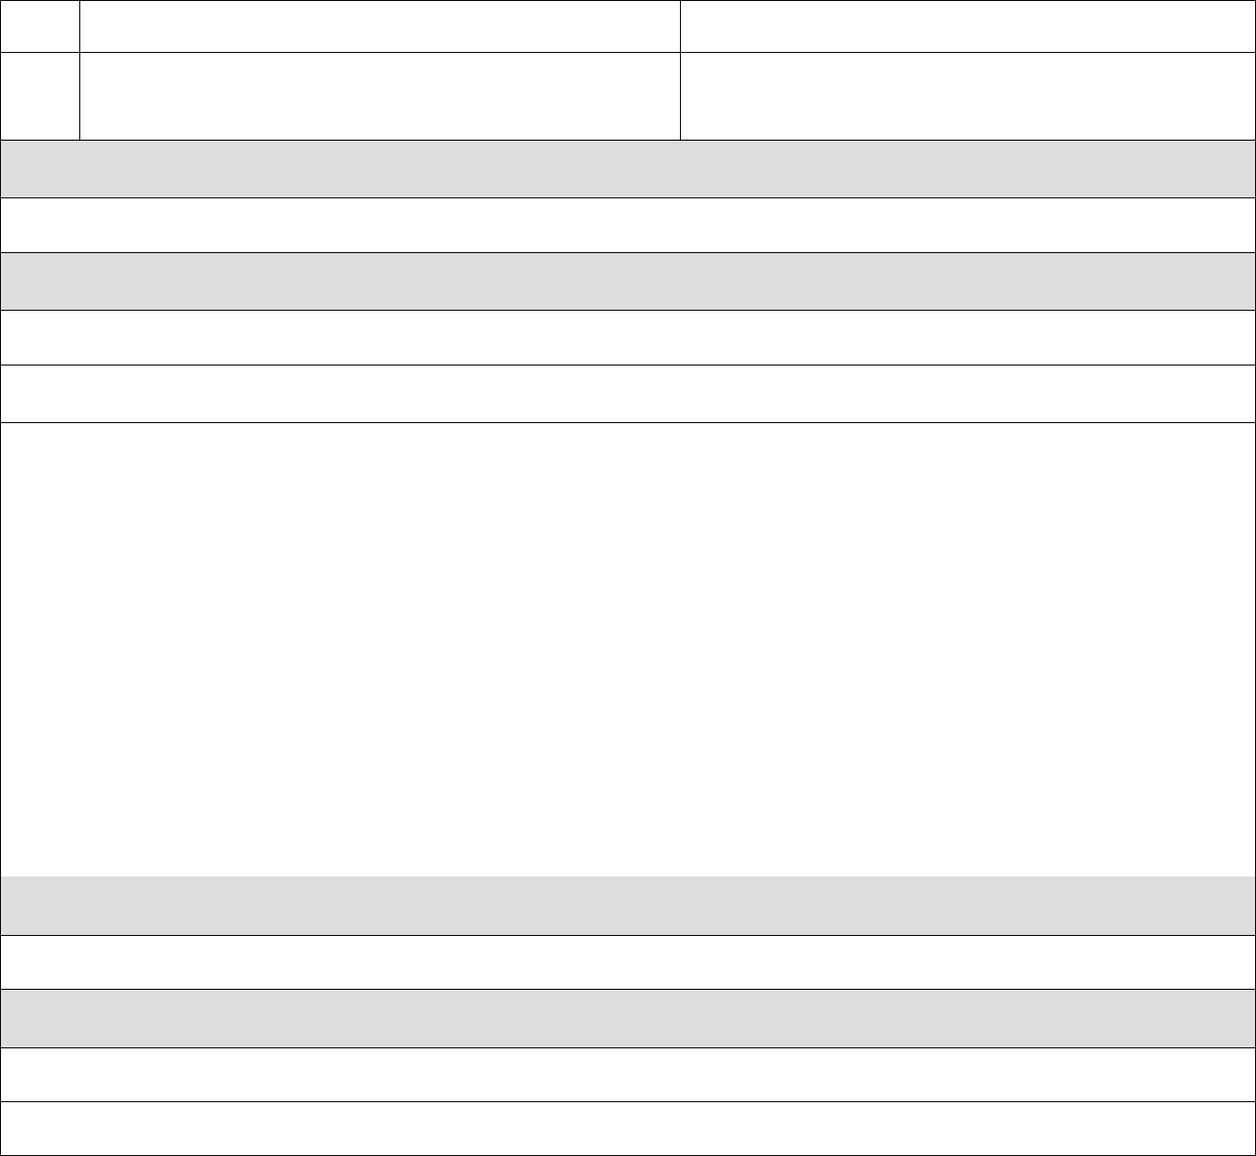
the block details pre-populated

- The admin changes the parts they want to update and The system updates the block record and returns a

requests the system to save the new details | success message or a fail message on exception.

Postconditions

The block details will be updated

Business Rule

The name, start and end dates should be unwritable.

1.1.3 Delete Block

Step | User Actions | System Actions
1 | The admin requests for a list of blocks | The system returns a list of all blocks.
2 | The admin selects to delete the block they want | The system displays a confirmation dialogue
 |  | window
3 | The admin selects OK on the confirmation dialog | The system checks that the block is not linked to
 | window to confirm deleting the block | any section and deletes the it and returns a success
 |  | message or a fail message on an exception.
 |  | Otherwise, it will return a message indicating the
 |  | block is associated to some sections.

Postconditions

The block will be deleted

Business Rule

The block must not be linked to some sections

Use Case Number: 4
Name |  |  | Entry CRUD
Brief description |  |  | This use case provides a functionality for managing Entry’s
Actors |  |  | Admin
Preconditions
The admin must log in to the system
Flows of Events:
1. Basic Flows
1.0 Create Entry
Step |  | User Actions |  | System Actions
1 |  | The admin calls the create Entry command |  | The system displays the create Entry form with name,
 |  |  |  | sequence number, start date and end date.
2 |  | The Admin enters the Entry start and end dates, the Entry |  | The system checks if there’s no other Entry with same
 |  | identifier number, and a name and requests the system to |  | name, start and end dates and saves the Entry and
 |  | save the details |  | returns a success message or a fail message on failure.
 |  |  |  | It should return a specific message when a duplicate
 |  |  |  | Entry exists.
Postconditions
The Entry is persisted in the system
Business Rules
A Entry must be unique. A unique block is identified by the name and the start and end dates
1.1 Read/view Entry
Step |  | User Actions |  | System Actions
1 |  | The admin requests for a list of Entry |  | The system returns a list of all Entry’s.
2 |  | The admin selects to view a Entry they want |  | The system returns the Entry object as a string
 |  |  |  | with Entry name, start and end dates
1.2 Update Entry
1 |  | The admin requests for a list of Entry |  | The system returns a list of all Entry’s.
2 |  | The admin selects the Entry they want to update |  | The system displays back an editable form with

the Entry details.

- The admin changes the parts they want to update, and the system updates the block record and returns a

requests the system to save the new details | success message or a failure message on exception.

Postconditions

The Entry details will be updated.

Business Rule

The name, start and end dates should be unwritable.

1.1.3 Delete Entry

Step | User Actions | System Actions
1 | The admin requests for a list of Entry | The system returns a list of all Entry’s.
2 | The admin selects to delete the Entry they want | The system displays a confirmation dialogue
 |  | window
3 | The admin selects OK on the confirmation dialog | The system checks that the Entry is not linked to
 | window to confirm deleting the Entry | any section and deletes the it and returns a success
 |  | message or a fail message on an exception.
 |  | Otherwise, it will return a message indicating the
 |  | Entry is associated to some sections.

Postconditions

The Entry will be deleted.

Business Rule

The Entry must not be linked to block.

Use Case Number: 5
Name |  |  | Schedule CRUD
Brief description |  |  | This use case provides a functionality for managing Schedule
Actors |  |  | Admin
Preconditions
The admin must log in to the system
Flows of Events:
1. Basic Flows
1.0 Create Entry
Step |  | User Actions |  | System Actions
1 |  | The admin calls the create Schedule command |  | The system displays the create Entry form with name,
 |  |  |  | sequence number, start date and end date.
2 |  | The Admin enters the Entry start and end dates, the Entry |  | The system checks if there’s no other Schedule with same
 |  | identifier number, and a name and requests the system to |  | name, start and end dates and saves the Schedule and
 |  | save the details |  | returns a success message or a fail message on failure.
 |  |  |  | It should return a specific message when a duplicate
 |  |  |  | Schedule exists.
Postconditions
The Schedule is persisted in the system
Business Rules
N/A
1.1 Read/view Entry
Step |  | User Actions |  | System Actions
1 |  | The admin requests for a list of Schedule |  | The system returns a list of all Schedule we have .
2 |  | The admin selects to view a Schedule they want |  | The system returns the Entry object as a string
 |  |  |  | with Schedule name, start and end dates
1.2 Update Entry
1 |  | The admin requests for a list of Schedule |  | The system returns a list of all Schedules.
2 |  | The admin selects the Schedule they want to update |  | The system displays back an editable form with

the Schedule details .

- The admin changes the parts they want to update and The system updates the block record and returns a

requests the system to save the new details | success message or a fail message on exception.

Postconditions

The Schedule details will be updated

Business Rule

The name, start and end dates should be unwritable.

1.1.3 Delete Entry

Step | User Actions | System Actions
1 | The admin requests for a list of Schedule | The system returns a list of all Schedules.
2 | The admin selects to delete the Schedule they want | The system displays a confirmation dialogue
 |  | window
3 | The admin selects OK on the confirmation dialog | The system checks that the Schedule is not linked to
 | window to confirm deleting the Schedule | any section and deletes the it and returns a success
 |  | message or a fail message on an exception.
 |  | Otherwise, it will return a message indicating the
 |  | Schedule is associated to some sections.

Postconditions

The Schedule will be deleted.

Business Rule

N/A.

